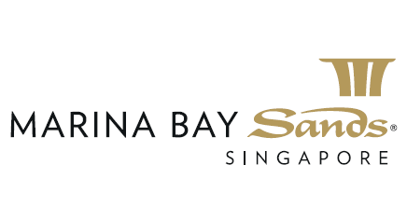

Promotion for Returning Guest
30 mins free upgrade, choice of Foot Massage OR Head & Shoulder Massage OR Express Facial.

Terms & Conditions:
- The offer is valid from 10 Feb 2020 to 31 Dec 2020.
- Applicable to the 2nd visit within 30days from the 1st visit.
- The offer cannot be used in conjunction with other discounts and promotions.
- Treatment is by appointment and subject to availability.
- Guest is required to present the receipt of the last treatment in order to enjoy the offer.
- The offer is applicable if the 1st treatment is Massage, Spa Packages and Facial Treatment.
- Payment by cash and credit cards issued by Visa, Master, JCB, Amex and UnionPay only.

