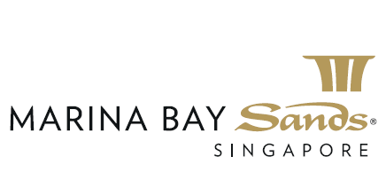

The Art of Romance
30mins Rose Scrub + 60mins choice of Massage + 30mins Milk & Rose bath

Terms & Conditions:

- This promotion is valid for same day reservation, and payment must be made under one receipt only.
- This promotion cannot be used in conjunction with any other promotion or discounts.
- Voucher payment is not accepted for this promotion.
- Sands Rewards Member will receive 3% earning.

